**Martin Garrix & Dua Lipa - Scared to be lonely**

Origineel: capo 4e fret.

**F Am G Em**

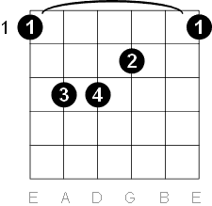 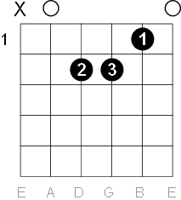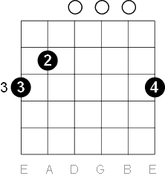 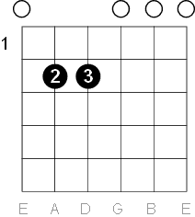

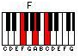 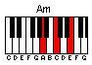 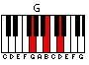 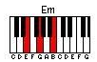

[Intro]  
  
F Am G Em  
  
  
[Couplet 1]  
  
 F Am  
It was great at the very start  
G Em  
Hands on each other  
 F Am  
Couldn't stand to be far apart  
G Em  
Closer the better  
  
  
[Pre-Chorus]  
 F  
Now we're picking fights  
 Am  
And slamming doors  
 G Em  
Magnifying all our flaws  
 F  
And I wonder why  
 Am  
Wonder what for  
 G Em  
Why we keep coming back for more  
  
  
[Refrein]  
  
F C   
 Is it just our bodies?  
G Am  
 Are we both losing our minds?  
F C G  
 Is the only reason you're holding me tonight  
 Am  
'Cause we're scared to be lonely?  
F C   
 Do we need somebody  
G Am  
 Just to feel like we're alright?  
F C G  
 Is the only reason you're holding me tonight  
 Am  
'Cause we're scared to be lonely?  
  
[Tussenstuk]  
  
F C G Am  
F C G Am  
  
  
[Couplet 2]  
  
 F Am  
Too much time, losing track of us  
G Em  
Where was the real?  
 F Am  
Undefined, spiraling out of touch  
 G Em  
Forgot how it feels  
  
  
[Pre-Chorus]  
 F  
All the fucked up fights  
 Am  
And slamming doors  
 G Em  
Magnifying all our flaws  
 F  
And I wonder why  
 Am  
Wonder what for  
 G Em  
It's like we keep coming back for more  
  
  
[Refrein]  
  
F C   
 Is it just our bodies?  
G Am  
 Are we both losing our minds?  
F C G  
 Is the only reason you're holding me tonight  
 Am  
'Cause we're scared to be lonely?  
F C   
 Do we need somebody  
G Am  
 Just to feel like we're alright?  
F C G  
 Is the only reason you're holding me tonight  
 Am  
'Cause we're scared to be lonely?  
  
[Tussenstuk]

F C G Am  
 Scared to be lonely  
F C G Am  
  
  
[Bridge]  
  
F Am  
Even when we know it's wrong  
 G Em  
Been somebody better for us all along  
 F Am  
Tell me, how can we keep holding on?  
 G  
Holding on tonight  
 Em  
'Cause we're scared to be lonely  
F Am  
Even when we know it's wrong  
 G Em  
Been somebody better for us all along  
 F Am  
Tell me, how can we keep holding on?  
 G  
Holding on tonight  
 Em  
'Cause we're scared to be lonely  
  
  
[Refrein]  
  
F C   
 Is it just our bodies?  
G Am  
 Are we both losing our minds?  
F C G  
 Is the only reason you're holding me tonight  
 Am  
'Cause we're scared to be lonely?  
  
  
F C G Am  
F C G Am  
 Scared to be lonely  
F C G Am  
 Scared to be lonely  
F C G Am  
 Scared to be lonely