**P!nk - What About Us**  
  
 Origineel: Capo 1e fret.

**Em C G**

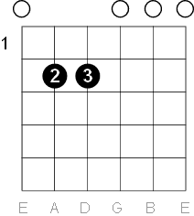 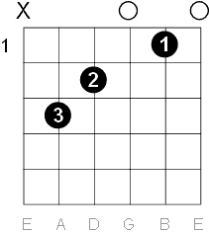 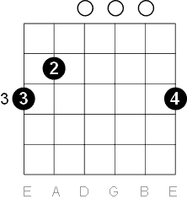

 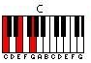 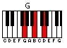

Em Emadd9 Em C Cadd9 G Gsus4  
e|3----2----0----0----0----3----3----|  
B|0----0----0----1----3----0----1----|

G|0----0----0----0----0----0----0----|

D|2----2----2----2----2----0----0----|   
A|2----2----2----3----3----2---------|  
E|0----0----0--------------3----3----|  
  
  
[Intro]  
 Em Emadd9 Em C Cadd9 C G Gsus4 G G Gsus4 G  
e|3--3--2--2--0---|0--0------------|----------------|----------------|  
B|--------------0-|------3--3--1---|0--0--1--1--0---|0--0--1--1--0---|  
G|----------------|--------------0-|--------------0-|--------------0-|  
D|----------------|----------------|----------------|----------------|  
A|----------------|3---------------|----------------|----------------|  
E|0---------------|----------------|3---------------|3---------------|

Em  
La da da da da  
C  
La da da da da  
G  
Da da da  
  
  
[Couplet 1]  
 Em C G  
We are searchlights, we can see in the dark  
 Em C G  
We are rockets, pointing up at the stars  
 Em C G  
We are billions of beautiful hearts  
 Em C G  
And you sold us down the river too far  
  
  
[Refrein]  
 Em  
What about us?  
 C G  
What about all the times you said you had the answers?  
 Em  
What about us?  
 C G  
What about all the broken happy ever afters?  
 Em  
What about us?  
 C G  
What about all the plans that ended in disaster?  
 Em C  
What about love? What about trust?  
 G  
What about us?  
  
  
[Couplet 2]  
 Em C G  
We are problems that want to be solved  
 Em C G  
We are children that need to be loved  
 Em C G  
We were willing, we came when you called  
 Em C G  
But man, you fooled us, enough is enough, oh  
  
  
[Refrein]  
 Em  
What about us?  
 C G  
What about all the times you said you had the answers?  
 Em  
What about us?  
 C G  
What about all the broken happy ever afters?  
 Em  
What about us?  
 C G  
What about all the plans that ended in disaster?  
 Em C  
What about love? What about trust?  
 G  
What about us?  
  
[Break]  
Em C G  
Em C G  
  
[Refrein]  
 Em  
What about us?  
 C G  
What about all the plans that ended in disaster?  
 Em C  
What about love? What about trust?  
 G  
What about us?  
  
  
[Bridge]  
Em C  
Sticks and stones they may break these bones  
 G  
But then I'll be ready, are you ready?  
Em C  
It's the start of us, waking up come on  
G  
Are you ready? I'll be ready  
Em C  
I don't want control, I want to let go  
G  
Are you ready? I'll be ready  
Em C  
'Cause now it's time to let them know  
G  
We are ready, what about us?  
  
  
[Refrein]  
 Em  
What about us?  
 C G  
What about all the times you said you had the answers?  
 Em  
What about us?  
 C G  
What about all the broken happy ever afters?  
 Em  
What about us?  
 C G  
What about all the plans that ended in disaster?  
 Em C  
What about love? What about trust?  
 G  
What about us?  
  
  
[Outro]  
 Em  
What about us?  
 C  
What about us?  
 G  
What about us?  
 Em  
What about us?  
 C  
What about us?  
  
What about us?