**John Legend - All of me**

**Em C G D**

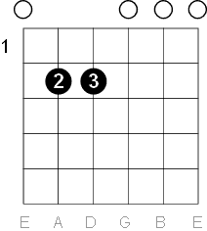 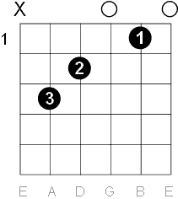 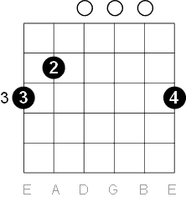 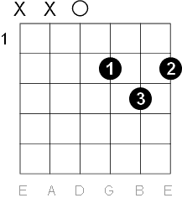

**Am**

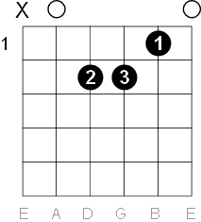

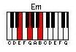 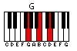 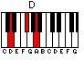 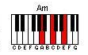

[Intro]

E + B

E + C

D + B

D + A

Em C G D

[Couplet 1]  
  
Em C G   
What would I do without your smart mouth  
 D Em  
Drawing me in, and kicking me out  
 C G D Em  
Got my head spinning, no kidding, I can’t pin you down  
 C G  
What’s going on in that beautiful mind  
 D Em  
I’m on your magical mystery ride  
 C G D Am  
And I’m so dizzy, don’t know what hit me, but I’ll be alright  
  
  
Am Em  
My head’s under water  
 D Am  
But I’m breathing fine  
Am Em D  
You’re crazy and I’m out of my mind

[Refrein]

G  
‘Cause all of me  
 Em  
Loves all of you  
 C  
Love your curves and all your edges  
 D  
All your perfect imperfections  
 G  
Give your all to me  
 Em  
I’ll give my all to you  
 C  
You’re my end and my beginning  
 D  
Even when I lose I’m winning  
 Em C G D  
‘Cause I give you all, all of me  
 Em C G D  
And you give me all, all of you, oh  
  
  
[Couplet 2]   
  
Em C G  
How many times do I have to tell you  
 D Em  
Even when you’re crying you’re beautiful too  
 C G D Em  
The world is beating you down, I’m around through every move  
 C G  
You’re my downfall, you’re my muse  
 D Em  
My worst distraction, my rhythm and blues  
 C G D Am  
I can’t stop singing, it’s ringing, in my head for you

Am Em  
My head’s under water  
 D Am  
But Im breathing fine  
 Em D  
You’re crazy and I’m out of my mind  
  
  
[Refrein]  
   
 G  
‘Cause all of me  
 Em  
Loves all of you  
 Am  
Love your curves and all your edges  
 D  
All your perfect imperfections  
 G  
Give your all to me  
 Em  
I’ll give my all to you  
 Am  
You’re my end and my beginning  
 D  
Even when I lose I’m winning  
 Em C G  
‘Cause I give you all, all of me  
 Em C G D  
And you give me all, all of you, oh  
   
  
[Bridge]

Am  
Give me all of you, oh

Em  
Cards on the table  
 D Am   
We’re both showing hearts  
Am Em D  
Risking it all, though it’s hard  
  
[Refrein]  
  
 G  
‘Cause all of me  
 Em  
Loves all of you  
 Am  
Love your curves and all your edges  
 D  
All your perfect imperfections  
 G  
Give your all to me  
 Em  
I’ll give my all to you  
 Am  
You’re my end and my beginning  
 D  
Even when I lose I’m winning  
 Em C G  
‘Cause I give you all, all of me  
 Em C G D  
And you give me all, all of you, oh  
 Em C G  
‘Cause I give you all, all of me  
 Em C G D

And you give me all, all of you, oh